nmi : spring 2024 : quiz 08 : ODEs, IVPs, usw

q1. (5 pts) back by popular demand: other than the final and any department lectures that occur after friday may 10, will any submissions be accepted after end-of-day friday may 10? choose one option.

▢ NO. ← i suggest this one.

*AND final and last department lectures must be submitted via blackboard no later than midnight friday may 17.*

q2. (5 pts) what information defines an initial value problem (IVP)?

q3. (5 pts) briefly describe what a solver is and give two examples.

q4. (5 pts) the diagram below shows global and local error. what is "z" and how does it relate to local error?

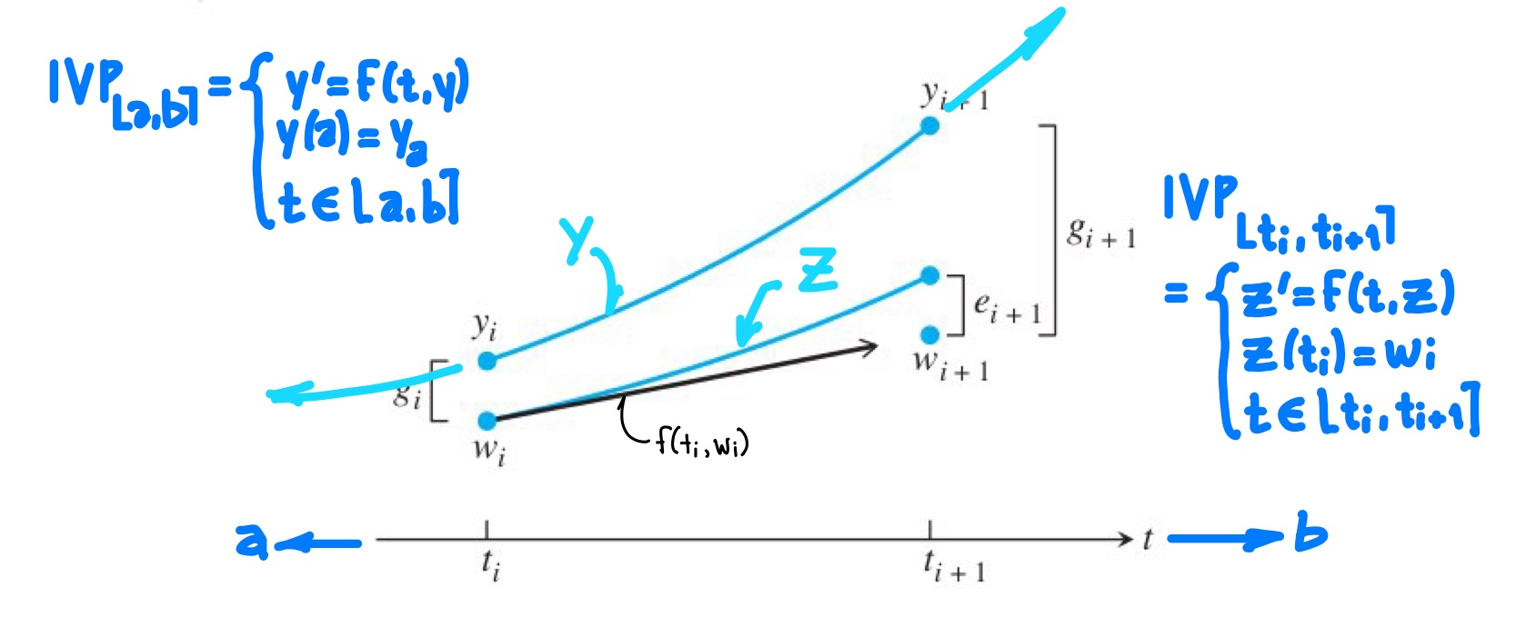

q5. (5 pts **MATH 685 ONLY**) briefly describe how the lipschitz constant is used wrt ODE solver convergence.

q6. (5 pts) during lecture wednesday 3/27, an implicit solver was used for what kind of problem?

q7. (5 pts extra credit) function scipy.integrate.solve_ivp was used as solver in an example during lecture wednesday 3/27. list the non-optional arguments and its default method.